2019 LONDON BLUE DEVILS

NOVICE 1 COMPETITIVE LACROSSE

Team Goals
Our goal this season is to be a top contender in the ‘A’ division for Ontario Lacrosse. We want to develop player skills, perfect the rules of lacrosse, instill respect for the game and our competitors and have fun.

Floor Times
Our scheduled floor times are Tuesdays and Thursdays at either 6pm or 7pm for practices. Please be sure to add the team calendar from londonlacrosse.com to your phone as practice times could change. There will be some weekend games in Windsor and in London and for tournament play.
The team staff also encourage all involved to subscribe to alerts for Novice 1. This will ensure you receive change notification and updates to our webpage either through email or text.
The manage subscriptions links are located at the bottom left of our webpage.
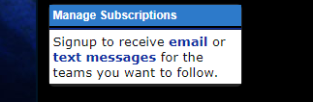
Once you click on the link, you will be asked enter your email address or phone for text messaging, then asked to select which team name and notifications you would like to have sent to you.
The team staff will try to email updates and team activity but subscribing to the team page will help to ensure you are made aware of changes more quickly. Please monitor our webpage as much as possible.
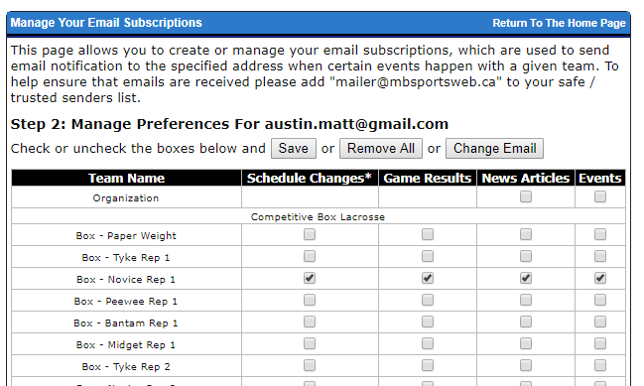

Tournament Participation
We have entered our team into 3 invitational tournaments this season.
- Barry Burman Summer Shootout – Orangeville June 21-23
- Bud Donovan Memorial Tournament – Oakville June 28-30
- Dan Greer Memorial Tournament – Clarington July 12-14
The Ontario Lacrosse Festival Provincial Championships for Novice is being held August 9-11th.

Team Fees
Novice 1 has secured 2 team sponsors this year to which will help keep our overall team fees low. A big thank you to MacMaster Chevrolet Cadillac Buick GMC Ltd. and Qdoba for supporting our team.
Also, LMLA covers one invitational tournament fee and our entry to the Provincials. The remainder of the entry fees will come from the participants.
Again for 2019 there will be a jersey deposit required by every player of the team. This is only a deposit. Once the jersey is returned at the end of the season the deposit cheques will be returned to the parent or destroyed. If the jersey is not returned in good condition, the cheque will be cashed for replacement costs by LMLA in accordance with the LMLA constitution.
Team fees per player are $100 (cheque payable to London Blue Devils or etransfer to boosterlmla@gmail.com)
Deadline for team fees and jersey deposit cheque is Thursday May 2nd at Practice. We need Jersey’s for May 5th games vs Wallaceburg.
Jersey deposit per player $100 (separate cheque required, payable to London Minor Lacrosse
*All players will receive team wear prior to the season. These costs were included in the registration cost. This includes team shorts, golf shirt, and warm up shirt.

Krossover Software
We will be recording our games and using Krossover to breakdown our game footage for review. This tool will help with areas for improvement, strategy and pointing out positive plays/behaviour.
We will require a volunteer to take care of setup and recording of games. This will most likely consist of setting up a go-pro or two and then uploading the game footage after games.

Player Profiles
Player Profiles and health information should be completed asap. This year we will be collecting Player Contact, Health and Bio information in an online form.
Please take some time and effort with your child and fill out the form.
This information will assist with player safety and coach/player development.

Team Rules

Practices
Players are expected to attend every practice unless a legitimate reason is emailed or phone messaged to the coaching staff. Providing notice to the coaching staff of any absence will allow for drills to be altered accordingly prior to practice. Please respect our program and communicate attendance with the coaching staff.
Players should be arriving early enough to be ready to take the floor on time.

Games
If a player is unable to attend a game or a tournament, please inform the coaching staff as soon as possible. Players need to ensure they have all equipment including mouth guards and jersey’s for games.
The coaching staff would like players to arrive to games at least 45 minutes before game time. The team will be conducting a warm up before the game and we want the kids to have sufficient time to get prepared and have a team discussion.
Team golf shirts must be worn by all players to all home, away, and tournament games. The warm up shirt and game shorts should be brought to every game and worn during our team warm up.

Dressing Room
Parents and individuals who are not a part of the coaching staff should not be entering the dressing room with the player. We would like the team to be more independent and responsible for getting ready before and after games/practices.
We want the dressing room to be for the kids and have it be their space.

Team Personnel
Head Coach – Nev Carson
k_carson9@fanshawec.ca 519-709-1905
Assistant Coach – Jon Low
Assistant Coach – Matt Austin
Assistant Coach – Tyler Turner
Assistant Coach – Colin Holbrough
Trainer – Jason Snowden
Team Manager – Chrissy Hobbs

Tournaments

Orangeville Tournament June 21-23, 2019
RCC King City $84.95 per night plus tax (Two Bedroom Suite)
www.stayrcc.com > Locations > King City > BOOK NOW > enter guest information and enter prom code BLUE2019
Hotel rooms must be booked by May 15th, 2019
Address: 13980 Dufferin Street, King City, Ontario, L7B 1L7, Canada
Phone: 905-833-1650

Oakville Tournament June 28-30, 2019
RCC Oakville $94.95 per night plus tax (Two Bedroom Suite)
1. Availability will only be on a first come, first serve basis so I would encourage you inform your group members to book quickly. Please send out the below link.
2. Please have your guest’s book online: https://app.thebookingbutton.com/properties/oakvilledirect Enter the arrival and departure dates, and within the Promotional Code box enter 748699 and click on apply. Then proceed to click on Show Rates. Once the rate appears click on Book to reserve.
Hotel rooms must be booked by May 28, 2019
Address: 2035 Cornwall Rd, Oakville, ON L6J 7S2
Phone: 905 337-7202

Clarington Tournament July 12-14, 2019
Holiday Inn Express Oshawa (King with Pullout) $135.00 a night
https://www.ihg.com/holidayinnexpress/hotels/us/en/oshawa/yoodt/hoteldetail/events-facilities?fromRedirect=true&qSrt=sBR&qIta=99801505&icdv=99801505&qSlH=YOODT&qGrpCd=LBD&setPMCookies=true&qDest=67%20Simcoe%20Street%20North,%20Oshawa,%20ON,%20CA&srb_u=1
Once your guests click on the link, they change the date of arrival and under “more options” your group “LBD” code will auto-generate.
Address: 67 Simcoe Street North, Oshawa ON L1G 4S3 Canada
Phone: 905-434-3666

Provincials August 8-11, 2019
Hotel Information (Booked Under 2019 London Blue Devils Novice 1)
RCC Oshawa $89.95 per night plus tax
Parents need to provide booking name and credit to Chrissy by May 25th to secure spots
Address: 32 Commencement Drive, Oshawa, ON, L1G 8G3, Canada
Phone: 905-728-8700

